**September 9, 2011**

**School**

**Name**

**Address**

**City, State Zip**

**Dear __________,**

**Crown Trophy of Flemington is pleased to introduce a new program to schools that will honor one (1) Student of the Month and two (2) Athletes of the Month (1 Male & 1 Female) at *no cost* to your school. This program has been very well received by schools serviced by our other Crown Trophy stores and now our corporate office has decided to roll it out to all stores nationwide.**

**We know that many school budgets have been cut and there just isn’t enough money for awards like this, but now in partnership with Crown Trophy of Flemington you can honor individuals that are deserving of such recognition. Our store proudly supports education (I had better, as my mother was a teacher for 35 years!) and we want to encourage young adults to do their best on and off the field at all times.**

**How does the program work? Simple, you, along with your fellow educators and coaches select one student and two athletes for each month. We let you select the criteria. For the Student of the Month Award, it could be based on overall GPA, contributions to student life, character, or involvement in clubs and organizations. For the Athlete of the Month it can be based on performance, character, grades, sportsmanship, etc.**

**We recommend that one person be the contact for the school with Crown Trophy of Flemington to email or fax us the recipients’ names at the end of each month. We in turn will engrave the plaques that you can either pick up in our store or we can deliver/ship them to your school for distribution. Some schools present the awards in homeroom and announce the recipients’ names in the morning announcements, other schools make a presentation at halftime of an upcoming football game or basketball game and invite the recipients’ families to be present**

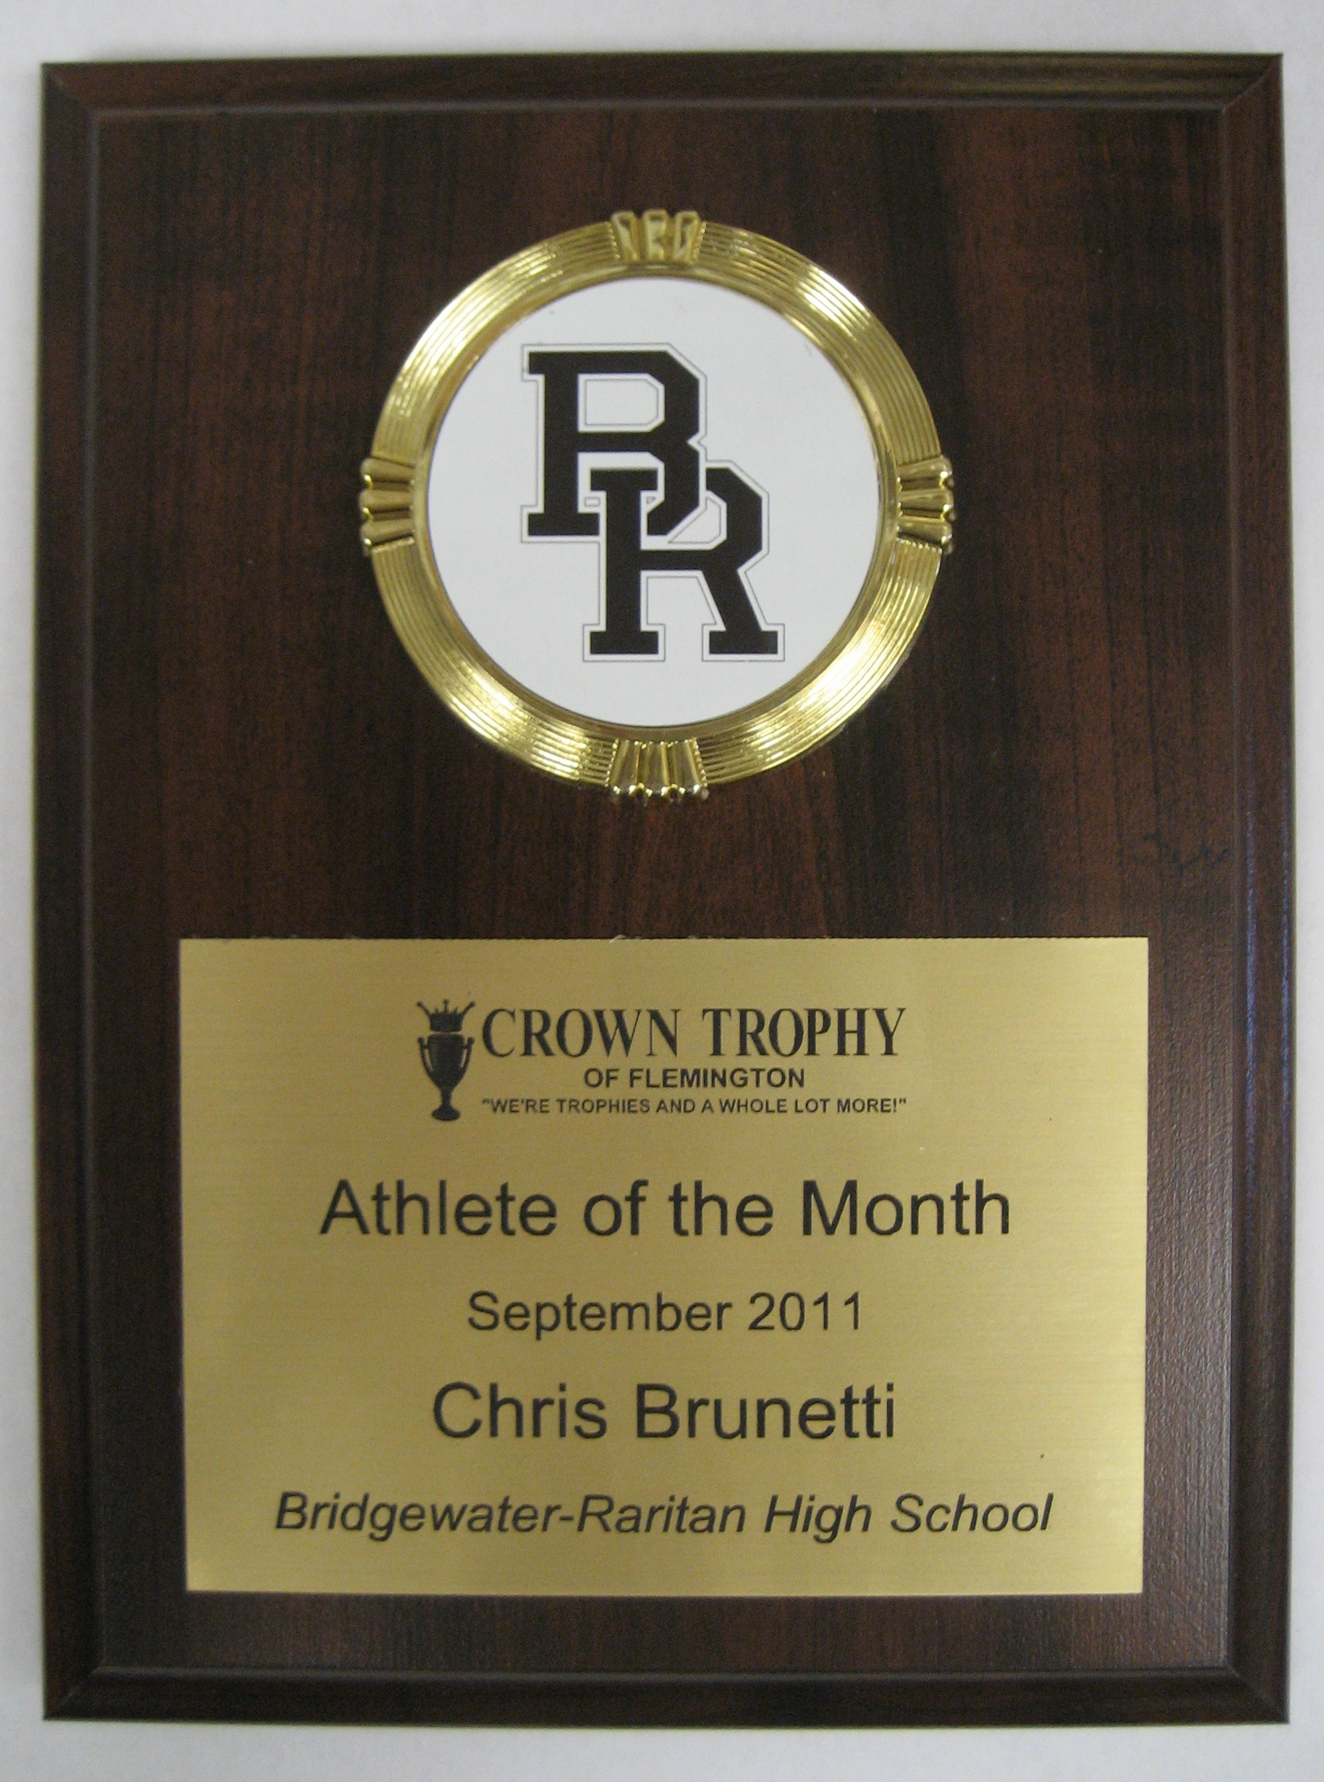

**as well.**

**Give us a call or email us using the above contact information**

**to discuss this program so we can get your school set up in our**

**system.**

**Pictured to the right is a sample of the plaque that will be**

**be presented to the recipient of the award, along with your**

**school logo.**

**Attached is a form you can use to fax in your recipient names for the current month, or you can simply email the information to us at** [**trophyjim@yahoo.com**](mailto:trophyjim@yahoo.com) **and indicate “Student Recognition” in the**

**subject line.**

**We hope you will take advantage of this great opportunity to recognize deserving young men and women in your school. Please feel free to contact me if you have any questions.**

**Sincerely,**

**Jim Gano**

**Owner – Crown Trophy of Flemington**

**JG/sf**

**Enclosure: Form**